DATA COMMUNICATION
Components
In order to send data/message from one point to another, following three components are must:
- Source
- Medium
- Receiver
RECEIVER
SOURCE
Message
Medium
Fig. 1 Components
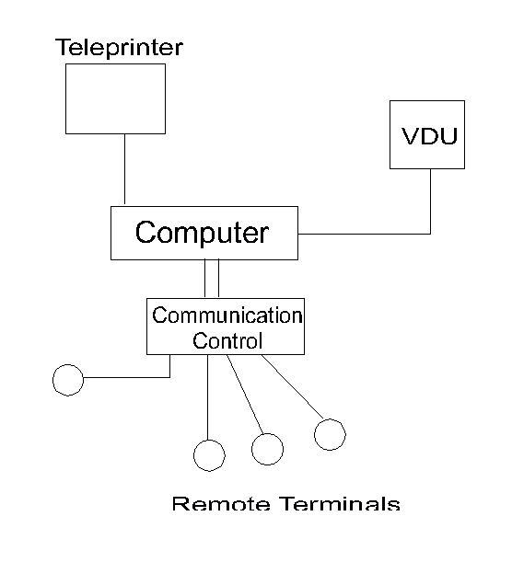
These elements are the minimum requirement for any communication process. In data communication, source and receiver data is called Data Terminal Equipment (DTE), e.g. A teleprinter or a computer terminal with keyboard. The medium may be a 2W telephone line or 2W/4W leased line. Let us see a simple data network (Fig.2).
Remote Terminals
Fig. 2 Simple Data Network
It involves a computer. One or more terminals (Remote Terminals) connected to the computer via communication lines.

Transmission Definitions
For understanding the data communication following terminology is discussed: -
- Communication lines
The medium that carries the message in a data communication system, e.g. A 2W telephone line.
- Communication Channel
A channel is defined as a means of one way transmission.
It can carry information in either direction but in only one direction at a time, e.g. A hose pipe. It can carry water in either direction, but the direction of flow depends on which end of pipe is connected to the water tap.
- Simplex Transmission
- Message always flows in one direction only.
- An input Terminal can only receive and never transmit.
- An O/P Terminal can only transmit and never receive.
We can say that it is a one-way communication. Electrical example of one-way communication system is given in Fig.3.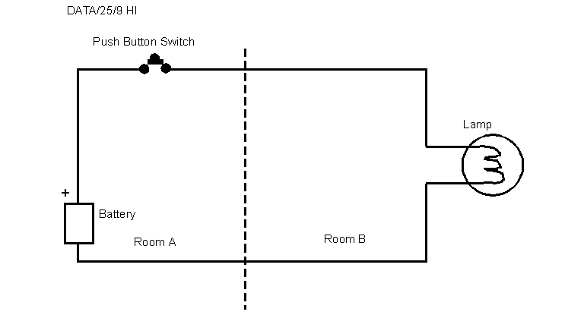
Fig. 3 Simplex Transmission
'A' can send information to 'B' by pressing the push button switch. Lamp will light in room B. When 'A' releases push button switch, lamp goes off.
By using some predetermined sequence of codes, A can communicate with B. However, there is no way that B can communicate with A.
- Half Duplex Transmission
- A half duplex channel can transmit and receive but not simultaneously.
- Transmission flow must halt each time and direction is to be reversed.
- This halt is called the turn-around time and is typically 8 to 10 ms in the case of leased circuits and 50-500 ms in case of 2W telephone line through Public Switched Telephone Network (PSTN).
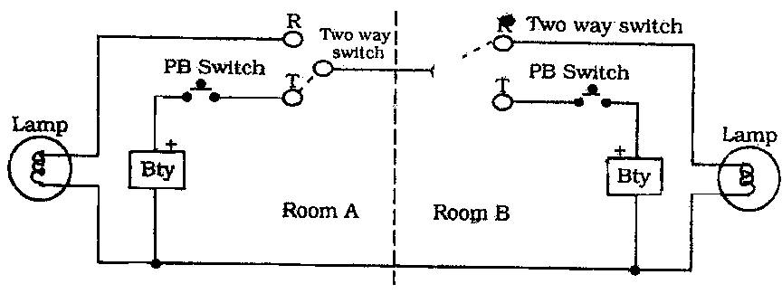
Fig. 4 Half Duplex Transmission
With above arrangement, A can communicate with B. If A is in transmit mode and B is in receive mode. At the end of communication, both persons can operate their two way switches to opposite positions and then B can communicate with A.
Turn-around Time is the sum of :-
- The time required to recognize that it is end of a transmission.
- The time required to physically switch the line at both ends so that direction of flow is reversed.
- Full-duplex Transmission
It is both way communication. If we set up a communication line with two channels, we have the capability of sending information in both directions at the same time. This is called full duplex transmission system.
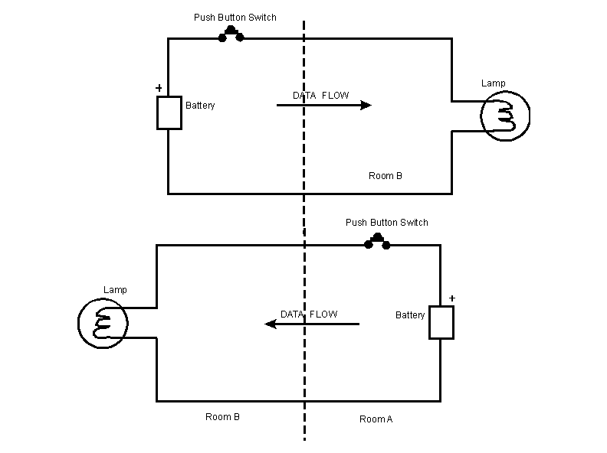
Simple electrical example is shown in Fig.5.
Full-Duplex Transmission
In the above arrangement, it is possible to have both way communication simultaneously. Thus, we need four wire for full-duplex transmission or both way simultaneous communication.
Transmission and Communication
Let us now understand the difference between transmission and communication. Transmission means physical movement of information from one point to another. Communication means meaningful exchange of information between the communicating devices.
Example
Two persons, one knowing English language only and the other knowing French language only cannot communicate with each other.
Here transmission is taking place, but communication is not there. Therefore, for communication, we need much more than the transmission. For communication, we must have the same language, i.e. Data codes should be understood both by transmitter and the receiver. Moreover, receiver should be in a position to receive, i.e. Timing is also very important.
We have two types of communication :
- Synchronous Communication.
- Asynchronous Communication.
Synchronous Communication
In Synchronous communication the exchange of information is in a well disciplined manner, e.g. if A want to send some information to B, it can do so only when B permits it to send. Similarly, vice-versa is true. There is complete synchronisation of dialogues, i.e. each message of the dialogue is either a command or a response. Physical transmission of data may be in synchronous or asynchronous mode already decided between A and B.
Asynchronous Communication
In Asynchronous communication the exchange of information is in less disciplined manner, e.g. A and B can send messages whenever they wish to do so. Physical transmission of data may be in synchronous / asynchronous mode.
Thus, we see that Simplex Transmission is one way communication (OW), Half Duplex Transmission is two way Alternate Communication (TWA), and Full Duplex Transmission is two way Simultaneously Communication (TWS).

chapter 2

osi reference modEl

CONTENTS

- Objectives
- Introduction
- Concept of data encapsulation
- Characteristics of the OSI Layers
- OSI Model and Communication Between Systems
- OSI layers

Chapter 2
OSI REFERENCE MODEL
Objectives
The objective of this chapter is to familiarize with : -
- Concept of data encapsulation
- Characteristics of the OSI Layers
- OSI Model and Communication Between Systems
- OSI layers
INTRODUCTION
The International Organization introduced the OSI layer for Standardization (ISO) in 1984 in order to provide a reference model to make sure products of different vendors would interoperate in networks. OSI is short for Open System Interconnection.
The OSI layer shows WHAT needs to be done to send data from an application on one computer, trough a network, to an application on another computer, not HOW it should be done. A layer in the OSI model communicates with three other layers: the layer above it, the layer below it, and the same layer at its communication partner. Data transmitted between software programs passes all 7 OSI layers. The Application, Presentation and Session layers are also known as the Upper Layers. 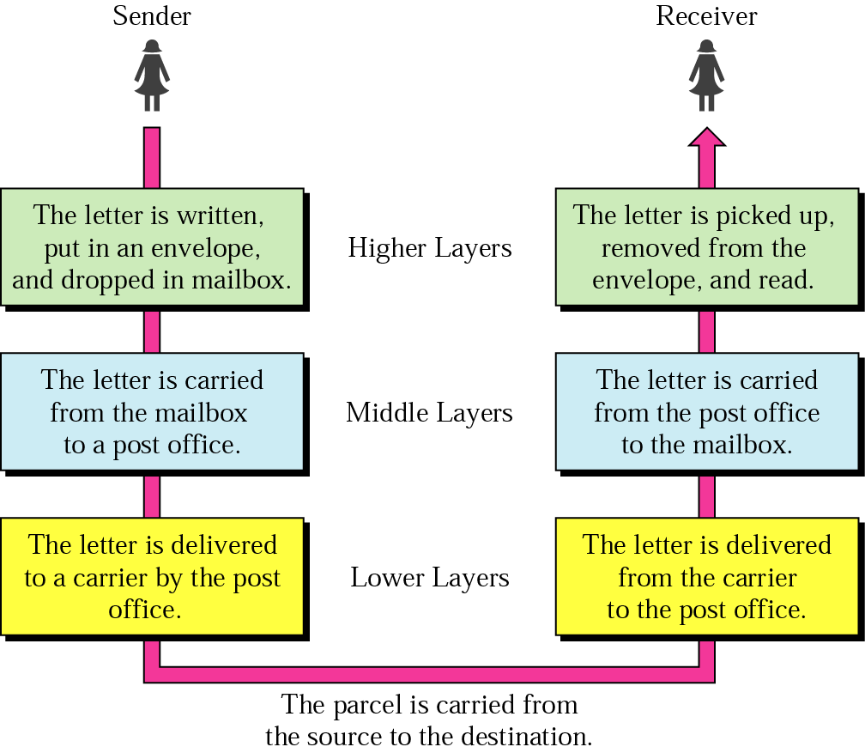
The Data Link and Physical layers are often
implemented together to define LAN / WAN
specifications.
- Application Layer
- Presentation Layer
- Session Layer
- Transport Layer
- Network Layer
- Data Link Layer
- Physical Layer

Data Encapsulation
Data Encapsulation is the process of adding a header to wrap the data that flows down the OSI model. Each OSI layer may add it's own header to the data received from above. (from the layer above or from the software program 'above' the Application layer.)
There are five steps of Data Encapsulation : -
- The Application, Presentation and Session layers create DATA from users' input.
- The Transport layer converts the DATA to SEGMENTS
- The Network layer converts the SEGMENTS to PACKETS (or datagrams)
- The Data Link layer converts the PACKETS to FRAMES
- The Physical layer converts the FRAMES to BITS.
At the sending computer the information goes from top to bottom while each layers divides the information received from upper layers in to smaller pieces and adds a header. At the receiving computer the information flows up the model discarding the corresponding header at each layer and putting the pieces back together.
The Figure shows layered model of two directly interconnected end systems. The transmission media is not included in the seven layers and, therefore, it can be regarded as layer number zero. Functions and services of various layers are described
Characteristics of the OSI Layers
The seven layers of the OSI reference model can be divided into two categories: upper layers and lower layers.
The upper layers of the OSI model deal with application issues and generally are implemented only in software. The highest layer, the application layer, is closest to the end user. Both users and application layer processes interact with software applications that contain a communications component. The term upper layer is sometimes used to refer to any layer above another layer in the OSI model.
The lower layers of the OSI model handle data transport issues. The physical layer and the data link layer are implemented in hardware and software. The lowest layer, the physical layer, is closest to the physical network medium (the network cabling, for example) and is responsible for actually placing information on the medium.
PROTOCOLS
The OSI model provides a conceptual framework for communication between computers, but the model itself is not a method of communication. Actual communication is made possible by using communication protocols. In the context of data networking, a protocol is a formal set of rules and conventions that governs how computers exchange information over a network medium. A protocol implements the functions of one or more of the OSI layers. A wide variety of communication protocols exist. Some of these include:
LAN protocols operate at the physical and data link layers of the OSI model and define communication over the various LAN media.
WAN protocols operate at the lowest three layers of the OSI model and define communication over the various wide-area media.
Routing protocols are network layer protocols that are responsible for exchanging information between routers so that the routers can select the proper path for network traffic.
Network protocols are the various upper-layer protocols that exist in a given protocol suite. Many protocols rely on others for operation.
For example, many routing protocols use network protocols to exchange information between routers. This concept of building upon the layers already in existence is the foundation of the OSI model.
OSI Model & Communication Between Systems
Information being transferred from a software application in one computer system to a software application in another must pass through the OSI layers. For example, if a software application in System A has information to transmit to a software application in System B. The application program in System A will pass its information to the application layer (Layer 7) of System A.
The application layer then passes the information to the presentation layer (Layer 6), which relays the data to the session layer (Layer 5), and so on down to the physical layer (Layer 1). At the physical layer, the information is placed on the physical network medium and is sent across the medium to System B. The physical layer of System B removes the information from the physical medium, and then its physical layer passes the information up to the data link layer (Layer 2), which passes it to the network layer (Layer 3), and so on, until it reaches the application layer (Layer 7) of System B. Finally, the application layer of System B passes the information to the recipient application program to complete the communication process.
Interaction between OSI model layers
A given layer in the OSI model generally communicates with three other OSI layers: the layer directly above it, the layer directly below it, and its peer layer in other networked computer systems. The data link layer in System A, for example, communicates with the network layer of System A, the physical layer of System A, and the data link layer in System B. Figure below illustrates this example.
System A System B

OSI Layer Services
One OSI layer communicates with another layer to make use of the services provided by the second layer. The services provided by adjacent layers help a given OSI layer communicate with its peer layer in other computer systems. Three basic elements are involved in layer services: the service user, the service provider, and the service access point (SAP).
In this context, the service user is the OSI layer that requests services from an adjacent OSI layer. The service provider is the OSI layer that provides services to service users. OSI layers can provide services to multiple service users. The SAP is a conceptual location at which one OSI layer can request the services of another OSI layer.
Application Layer (Layer 7)
Application Layer provides network services directly to applications. Type of software programs vary a lot: from groupware and web browser to Tactical Ops (video game). Software programs itself are not part of the OSI model. It determines the identity and availability of communication partners, and determines if sufficient resources are available to start program-to-program communication. This layer is closest to the user. Gateways operate at this layer. Following are the examples of Application layer protocols:
- Telnet
- SMTP
- FTP
- SNMP
- NCP
- SMB
Presentation Layer (Layer 6)
Presentation Layer defines coding and conversion functions. It ensures that information sent from the application layer of one system is readable by the application layer of another system. It includes common data representation formats, conversion of character representation formats, common data compression schemes, and common data encryption schemes, common examples of these formats and schemes are:
- MPEG, QuickTime
- ASCII, EBCDIC
- GIF, TIFF, JPEG
Gateways operate at this layer. It transmits data to lower layers.
Session Layer (Layer 5)
The session layer establishes, manages, maintains and terminates communication channels between software programs on network nodes. It provides error reporting for the Application and Presentation layer. Examples of Session layer protocols are:
- NFS
- SQL
- RPC
- Zone Information Protocol (ZIP)
Gateways operate at this layer. It transmits data to lower layers.
Transport Layer (Layer 4)
The main purpose of this layers is making sure that the data is delivered error-free and in the correct sequence. It establishes, maintains and terminates virtual circuits. It provides error detection and recovery. It is concerned with reliable and unreliable transport. When using a connection-oriented, reliable transport protocol, such as TCP, acknowledgments is send back to the sender to confirm that the data has been received. It provides Flow Control and Windowing. It provides multiplexing; the support of different flows of data to different applications on the same host. Examples of Transport layer protocols are:
- TCP (connection-oriented, reliable, provides guaranteed delivery.)
- UDP (connectionless, unreliable, less overhead, reliability can be provided by the Application layer)
- SPX
Gateways operate at this layer. It transmits data to lower layers.
Network Layer (Layer 3)
This layer defines logical addressing for nodes and networks/segments. It enables internetworking, passing data from one network to another. It defines the logical network layout so routers can determine how to forward packets trough an internet-work. Routing occurs at this layer, hence Routed and Routing protocols reside on this layer. Routed protocols are used to encapsulate data into packets. The header added by the Network layer contains a network address so it can be routed trough an internet-work. Examples of Network layer Routed protocols are:
- IP
- IPX
- AppleTalk
Routing protocols are used to create routing tables; routing tables are used to determine the best path / route. Routing protocols provide periodic communication between routers in an Internet work to maintain information on network links in a routing table. It transmits Packets. Routers operate at this layer. Examples of Network layer Routing protocols are:
- OSPF
- IGRP/EIGRP
- RIP
- BGP
- NLSP
Data Link Layer (Layer 2)
It defines psychical addressing, network topology, and is also concerned with error notification, sequencing of frames and flow control. Examples of network topologies are:
- Star
- Bus
- Ring
Physical addresses are also known as hardware and BIA's (Burned In Addressess) but most commonly as MAC addresses. Examples of Data Link LAN specifications are:
- Ethernet
- Fast Ethernet
- Token Ring
- FDDI
Examples of Data Link WAN specifications are:
- Frame Relay (operates also on the Physical layer)
- PPP (operates also on the Physical layer)
- X.25 (operates also on the Physical and Network layer)
Data Link layer Transmits Frames. Bridges and Switches operate at this layer.The Data Link layer consists of two sub-layers:
  - LCC (Logical Link Control) Layer
Manages communication between devices over a single link of a network. Enables multiple higher-layer protocols to share a single physical data link.
  - MAC Layer
Manages protocol access to the physical network medium and determines hardware addresses.
Physical Layer (Layer 1)
The physical layer defines the electrical, mechanical, procedural, and functional specifications for activating, maintaining, and deactivating the physical link between communicating network systems. It transmits and receives bits (bit stream) to transmission media. Physical layer specifications define characteristics such as:
  - Voltage levels
  - Timing of voltage changes
  - Physical data rates
  - Maximum transmission distances
  - Physical connectors
Physical layer implementations can be categorized as either LAN or WAN specifications. The examples of LAN and WAN specifications are given below: -
LAN specifications
- Ethernet
- Fast Ethernet
- Token Ring
- FDDI
WAN specifications are:
- HSSI
- V.24
- V.35
- BRI
- SLIP
- RS-232
The core of this standard is the OSI Reference Model, a set of seven layers that define the different stages that data must go through to travel from one device to another over a network.
SUMMARY
The core of this standard is the OSI Reference Model, a set of seven layers that define the different stages that data must go through to travel from one device to another over a network. Think of the layers as the assembly line in the computer. At each layer, certain things happen to the data that prepare it for the next layer. The seven layers, which separate into two sets, are:
- Application Set:
- Layer 7: Application - This is the layer that actually interacts with the operating system or application whenever the user chooses to transfer files, read messages or perform other network-related activities.
- Layer 6: Presentation - Takes the data provided by the Application layer and converts it into a standard format that the other layers can understand.
- Layer 5: Session - Establishes, maintains and ends communication with the receiving device.
- Transport Set:
- Layer 4: Transport - This layer maintains flow control of data and provides for error checking and recovery of data between the devices. Flow control means that the Transport layer looks to see if data is coming from more than one application and integrates each application's data into a single stream for the physical network.
- Layer 3: Network - The way that the data will be sent to the recipient device is determined in this layer. Logical protocols, routing and addressing are handled here.
- Layer 2: Data - In this layer, the appropriate physical protocol is assigned to the data. Also, the type of network and the packet sequencing is defined.
- Layer 1: Physical - This is the level of the actual hardware. It defines the physical characteristics of the network such as connections, voltage levels and timing

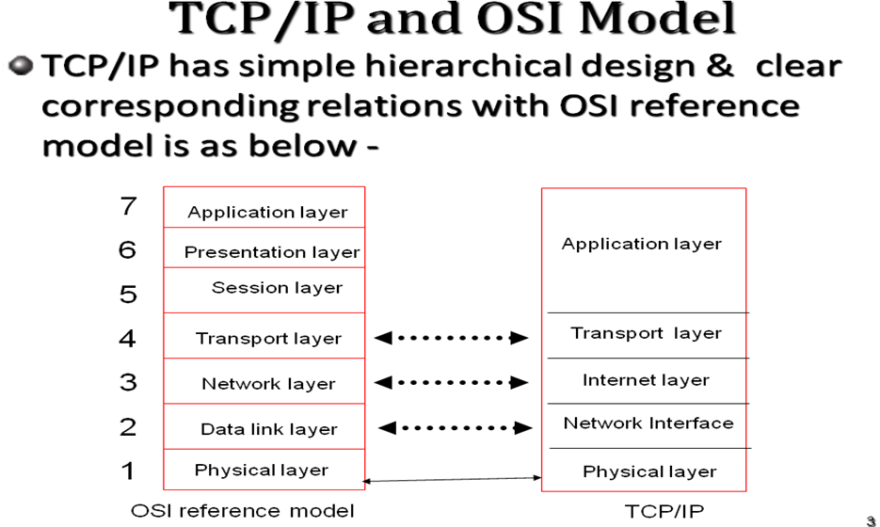
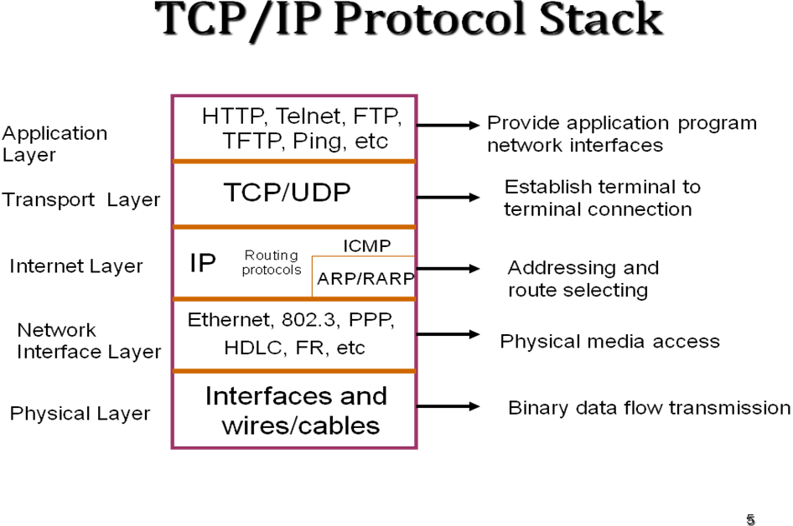
TCP/IP has four abstraction layers. This layer architecture is often compared with the seven-layer OSI Reference ModelThe TCP/IP model and related protocols are maintained by the Internet Engineering Task Force (IETF).

network COMPONENTS
fundamentals of networking

Objectives
The objectives of this chapter are to familiarize with the following: -
- The LAN components
- Repeater
- Hub
- Bridge
- Router
- Gateway
- Understand the Networking
INTRODUCTION
Information does not exist in a vacuum. Just as the need to share in formation between desktop computers in an office has forced the proliferation of LANs, the need to share information beyond a single workgroup is forcing the adoption of LAN-to-LAN links, host gateways, asynchronous communication servers, and other methods of communicating with other systems.
LAN COMPONENTS
Local Area Network is a high speed, low error data network covering a relatively small geographic area. LAN connects workstations, peripherals, terminal and other devices in a single building or other geographically limited area. LAN standard specifies cabling and signaling at the physical and data link layers of the OSI model. Ethernet, FDDI and Token ring are widely used LAN technology. In LAN technology to solve the congestion problem and increase the networking performance single Ethernet segment is to divide into multiple network segments. This is achieved through various network components. Physical segmentation, network switching technology, using full duplex Ethernet devices, fast Ethernet and FDDI available bandwidth may be maximized.
REPEATERS
Repeaters are devices that amplify and reshape the signals on one LAN& pass them to another. A repeater forwards all traffic from one LAN to the other. Repeaters are usually used to extend LAN cable distances or connect different media type.
Repeaters connect LANs together at the lowest layer, the Physical layer, of the OSI model. This means that repeaters can only connect identical LANs, such as Ethernet/802.3 to Ethernet/802.3 or Token Ring to Token Ring.

7-APPLICATION

3 NETWORK
2. DATA LINK
1. Physical

2-DATA LINK

1-PHYSICAL

GATEWAYS

ROUTER
BRIDGE/SWITCH
REPEATER/HUB

ROUTER

BRIDGE/SWITCH

REPEATER/HUB

OSI MODEL
LANINTERCONNECTION DEVICE

Fig. 1
Two physical LANs connected by a repeater become one physical LAN. Because of this, the proper use and placement of repeaters is specified as part of LAN architecture’s cabling parameters.
HUB
As its name implies, a hub is a center of activity. In more specific network terms, a hub, or concentrator, is a common wiring point for networks that are based around a star topology. Arcnet, 10base-T, and 10base-F, as well as many other proprietary network topologies, all rely on the use of hubs to connect different cable runs and to distribute data across the various segments of a network. Hubs basically act as a signal splitter. They take all of the signals they receive in through one port and redistribute it out through all ports. Some hubs actually regenerate weak signals before re-transmitting them. Other hubs retime the signal to provide true synchronous data communication between all ports. Hubs with multiple 10base-F connectors actually use mirrors to split the beam of light among the various ports.
Passive Hubs
Passive hubs, as the name suggests, are rather quiescent creatures. They do not do very much to enhance the performance of your LAN, nor do they do anything to assist you in troubleshooting faulty hardware or finding performance bottlenecks. They simply take all of the packets they receive on a single port and rebroadcast them across all ports--the simplest thing that a hub can do.
Passive hubs commonly have one 10base-2 port in addition to the RJ-45 connectors that connect each LAN device. 10base-5 is 10Mbps Ethernet that is run over thick-coax. This 10base-2 connector can be used as network backbone. Other, more advanced passive hubs have AUI ports that can be connected to the transceiver to form a backbone that may be more advantageous.
Most passive hubs are excellent entry-level devices that can be used as starting points in the world of star topology Ethernet. Most eight-port passive hubs are cheaper.
Active Hubs
Active hubs actually do something other than simply re-broadcasting data. Generally, they have all of the features of passive hubs, with the added bonus of actually watching the data being sent out. Active hubs take a larger role in Ethernet communications by implementing a technology called store & forward where the hubs actually look at the data they are transmitting before sending it. This is not to say that the hub prioritizes certain packets of data; it does, however, repair certain "damaged" packets and will retime the distribution of other packets.
If a signal received by an active hub is weak but still readable, the active hub restores the signal to a stronger state before re-broadcasting it. This feature allows certain devices that are not operating within optimal parameters to still be used on your network. If a device is not broadcasting a signal strong enough to be seen by other devices on a network that uses passive hubs, the signal amplification provided by an active hub may allow that device to continue to function on your LAN. Additionally, some active hubs will report devices on your network that are not fully functional. In this way, active hubs also provide certain diagnostic capabilities for your network.
Active hubs will also retime and resynchronize certain packets when they are being transmitted. Certain cable runs may experience electromagnetic (EM) disturbances that prevent packets from reaching the hub or the device at the end of the cable run in timely fashion. In other situations, the packets may not reach the destination at all. Active hubs can compensate for packet loss by re-transmitting packets on individual ports as they are called for and re-timing packet delivery for slower, more error-prone connections. Of course, re-timing packet delivery slows down overall network performance for all devices connected to that particular hub, but sometimes that is preferable to data loss--especially since the re-timing can actually lower the number of collisions seen on LAN. If data does not have to be broadcast over and over again, the LAN is available for use for new requests more frequently. Again, it is important to point out that active hubs can help you diagnose bad cable runs by showing which port on your hub warrants the retransmission or re-timing.
Intelligent Hubs
Intelligent hubs offer many advantages over passive and active hubs. Organizations looking to expand their networking capabilities so users can share resources more efficiently and function more quickly can benefit greatly from intelligent hubs. The technology behind intelligent hubs has only become available in recent years and many organizations may not have had the chance to benefit from them; nevertheless intelligent hubs are a proven technology that can deliver unparalleled performance for LAN.
In addition to all of the features found in active hubs, incorporating intelligent hubs into your network infrastructure gives you the ability to manage your network from one central location. If a problem develops with any device on a network connected to an intelligent hub, it can easily identify, diagnose, and remedy the problem using the management information provided by each intelligent hub. This is a significant improvement over standard active hubs. Troubleshooting a large enterprise-scale network without a centralized management tool that can help you visualize your network infrastructure usually leaves you running from wiring closet to wiring closet trying to find poorly functioning devices.
Bridges
Bridges connect LANs together at the Data Link layer of the OSI model. Specifically bridges connect at the Media Access Control (MAC) sub-layer of the Data Link layer, and are often referred to as MAC-layer bridges. In the past,
Bridges connect similar or identical LANs. Bridges can be used to connect Ethernet/ 802.3 to Ethernet/ 802.3, 10-Mbps Ethernet/802.3 to 1-Mbps Star LAN, 4-Mbps Token Ring to 4-Mbps Token Ring, or 4-Mbps Token Ring to 16-Mbps Token Ring. Like repeaters, bridges can be used to connect LANs using different media (10BASE-T to 10BASE5, for example).
Bridges are transparent to the network-layer protocols (such as IPX and IP) being used on the network. Two networks connected via a bridge are physically separate network, but logically a single network. This means that a network’s cabling rules apply to each individual network, not both collectively, but Network-layer protocols will address the bridged network as if they were one.
Bridges segment traffic by only forwarding traffic that is addressed to stations on the opposite side of the bridge. This means that bridges do not forward local traffic. This can considerably reduce overall traffic in a multi-LAN inter-network.
Transparent Bridges
The type of bridges used for Ethernet/802.3 LANs is called a transparent bridge. This is because the existence of the bridge is transparent to workstations, file servers and other network devices. The bridge performs all the functions necessary to route traffic between bridged networks.
Transparent bridges keep routing tables of physical addresses of network devices and forward traffic based on the locations of the particular network device to which packets are being sent. Early bridges required the system administrator to manually build the routing tables. Current bridges automatically learn station addresses and build the routing tables and are sometimes referred to as learning bridges.
Spanning Tree Algorithm
Transparent bridges to not allow redundant paths. By using a scheme called the Spanning Tree Algorithm, however, alternate paths are allowed. In simplest terms, the Spanning Tree Algorithm ensures that only one bridge path between any two networks is active at a time. If a bridge path fails, another bridge path (if it exists) will automatically be activated. Not all bridges support the Spanning Tree Algorithm, and although Spanning Tree Algorithm is now part of the IEEE 802 specifications, not all bridges that support the Spanning Tree Algorithm conform with the IEEE specifications.
Source Routing Bridges
Although transparent bridging can be used with Token Ring Networks, IBM has promoted another bridging method called source routing. With source routing, the bridge does not keep track of the route by which packets are sent. Each network node that initiates communication with another node across one or more bridges must keep track of the route used. Unlike transparent bridges, source routing bridges allow redundant paths.
To establish a route, the station initiating communication broadcasts a discovery packet, which makes its way through the Network’s source routing bridges. The discovery packet keeps track of the bridges it crosses on the way to the destination. Depending on the configuration of the bridges and the method used to send the discovery packet (the description of which is beyond the scope of this book), the discovery packet will arrive at the destination via one or more routes, meaning one or more copies of the discovery packet will be received at the destination.
The destination returns its response(s) using reverse addressing, meaning it uses each discovery packet’s list of crossed bridges, in reverse order, to return its response(s). If the initiating station receives responses via more than one route, the first response received establishes the route to be used.
ROUTERS
Routers connect LANs at the Network layer of the OSI model Routers connect LANs that use the same Network-layer protocol, such as IPX-to-IPX and IP-to-IP. Because routers operate at the Network layer, they can be used to link dissimilar LANs, such as ARCNET, Ethernet, and Token Ring.
Two networks connected via a router are physically and logically separate networks. Network-layer protocols have their own addressing scheme separate from the addressing scheme of MAC-layer protocols. This addressing scheme may or may not include the MAC-layer addresses of the network cards. Each network attached to a router must be assigned a logical identifier, or network address, to designate it as unique from other physical networks.
For example, NetWare’s IPX routers (NetWare file servers or external NetWare routers using ROUTER.EXE) use each LAN card’s MAC-layer address and a logical address for each network assigned by the router installer.
A router can support single or multiple Network-layer protocols. Net Ware 2.2 File servers and Net Ware external routers, for example, only support NetWare’s IPX protocol. NetWare 3.11 file servers. Routers on the other hand, can route IPX, IP and Apple Talk, if the proper routing software is loaded into the file server. Dedicated routers from Proteon, Cisco, Welfleet, and others can route a number of different protocols.

Station

Station

Station
LAN A
LAN B
Point-to-Point Link, Heterogeneous LANs

Station

Station

Station

Station
LAN B
LAN
A
Wide-area
packet Switching Network
Wide-Area Network Link, Heterogeneous LANs

Fig. 7.4

Station

Router

Station
LAN to Host Link
LAN

Like bridges, routers only forward traffic addressed to the other side. This means that local traffic on one LAN will not affect performance on another. Again, like bridges, routers can be proprietary devices, or can be software and hardware residing in a general purpose computer, such as a PC.
Like transparent bridges, routers maintain routing tables. A router’s routing table, however, keeps track of network addresses and possible routes between networks, not individual node addresses. Using routers, redundant paths between networks can be established, and traffic will be routed between networks based on some algorithm to determine the best path. The simplest routers usually select the path with the fewest number of router hops as the best path. More intelligent routers consider other factors, such as the relative response times of various possible routes, when selecting the best path.
Because routers operate at the network layer, they can connect dissimilar types of LANs, such as ARCNET and Ethernet. LAN cards using different frame types, such as 802.3 and Ethernet II, can co-exist on the same LAN cable, but are actually separate logical networks. A router can connect two or more such logical networks.
Routing is more complex than bridging, and, all other things being equal, routers are somewhat slower than bridges. Routers usually do not provide the extensive filtering capabilities that some bridges do. Another downside to routers is that there are few standards, so different vendor’s products may not inter operate. Routers do provide better network segmentation than bridges, however, so that things like broadcast packet storms will not affect an entire inter-network.

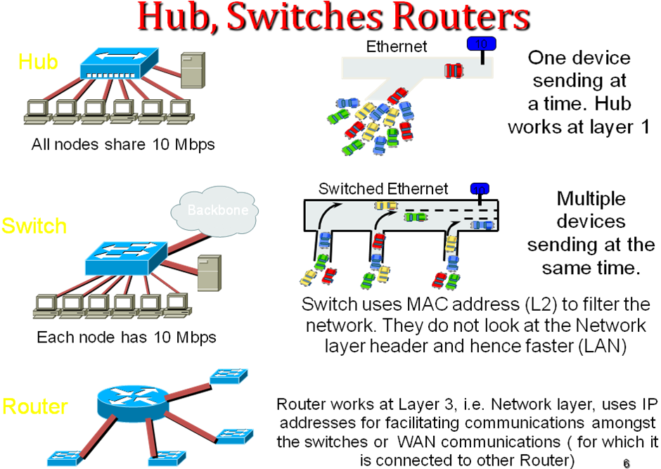

GATEWAYS
A gateway is a fundamentally different type of device than a repeater, bridge, router, or switch and can be used in conjunction with them. A gateway makes it possible for an application program, running on a system, confirming to network architecture, to communicate with an application program running on a system confirming to some other network architecture.
A gateway performs its function in the Applicatio0n layer of the OSI model. The function of a gateway is to convert one set of communication protocols to some other set of communication protocols. Protocol conversion may include the following:
- Message Format Conversion- Different networks may employ different message format, maximum message size, or character codes. The gateway must be able to convert messages to appropriate format, size and coding.
- Address translation- Different networks may employ different addressing mechanism and network address structures. The gateway must be able to interpret network address in one network and convert them into network address in other network.
- Protocol conversion- When a message is prepared for transmission, each layer adds control information, unique to the protocol used in that layer. The gateway must be able to convert control information used by each layer so that the receiving system receives the control information in the format it expects. Services affected may include message segmentation and reassembly, data flow control, and error detection and recovery.
Network Service Types
There are two types of Network Services one is known as Connectionless (or Datagram) and the other is Connection-Oriented (or Virtual Circuit).
- Connectionless Service
In connectionless service the end node transmits with every piece of data the address to which the data should be delivered. Every piece of data called packet is independently routed, so the network can't guarantee that all the packets will reach the destination in the transmitting order since the packets can be delivered through more then one path.
- Connection-Oriented Service
In connection-oriented service the end node first informs the network it wishes to start a conversation with another end node, the network sends it's request to the destination that accepts or rejects the request. If the destination refuses, connection fails, otherwise connection is established.
Connection-Oriented service usually has the following characteristics:
- The network guarantees that all packets will be delivered in order without loss or duplication of data.
- Only a single path is established for the call, and all the data follows that path.
- The network guarantees a minimal amount of bandwidth and this bandwidth is reserved for the duration of the call.
- If the network becomes overly utilized, future call requests are refused.
Following are few examples of applications, which need the connection-oriented service or connectionless service.
- File transfer and remote terminal protocols will not tolerate loss of data, and require the packets to remain ordered. This kind of application dictates a connection-oriented service.
- Electronic mail do not requires that packets remain ordered. Speech conveying systems can tolerate a modest percentage of lost packets. In packet voice, receiving delayed packets is actually useless. This kind of application dictates connectionless service.
PHYSICAL LAYER STANDARDS
DTE: Data Terminal Equipment (PC, Terminal, Printer)
DCE: Data Communications Equipment (Modem, Mux, Host/Mainframe)
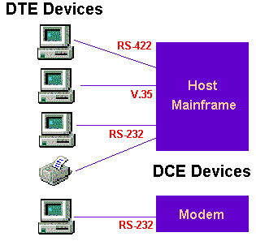

RS-232 (V.24)== RS-232 is a very popular interface for low speed data signals. It is an unbalanced interface capable of operation from 0 to 20 KBPS at 50 feet. RS-232 is a voltage sensing interface, with the Mark (1) voltage being from -3 to -25 VDC and the Space (0) voltage being from +3 to +25 VDC.
V.35 ============= V.35 (.35 is an interface (ITU - formerly CCITT standard) is a high-speed serial interface designed to support both higher data rates and connectivity between DTEs (data-terminal equipment) or DCEs (data-communication equipment) over digital lines. Although V.35 is commonly used to support speeds ranging anywhere from 48 to 64 Kbps, much higher rates are possible [ ISDN (64 or 128Kbps), Factional T1@ 128 Kbps to 1.544Mbps T1, ATM and Frame Relay]. Max speed is 2 Mbit/s.
G703 ========== G.703 is an ITU-T standard for transmitting voice or data over digital carriers such as T1 and E1. G.703 provides specifications for pulse code modulation (PCM). G.703 also specifies E0 (64kbit/s). G.703 is either transported over 75 ohm co-axial cable terminated in BNC or Type 43 connectors or 120 ohm twisted pair cables terminated inRJ48C jacks.
HSSI============= The High- Speed Serial Interface (HSSI) is differential ECL serial interface standard developed by Cisco Systems and T3plus Networkingprimarily for use in WAN router connections. It is capable of speeds up to 52 Mbit/s with cables up to 50 feet in length.
While HSSI uses 50-pin connector physically similar to that used by SCSI-2, it requires a cable with an impedance of 110Ω (as opposed to the 75Ω of a SCSI-2 cable).

DATA LINK LAYER PROTOCOLS

Data link layer having two sub-layers - LLC sublayer & MAC sublayer
- Encapsulation of network layer data packets into frames
- Frame synchronization
- Logical link control (LLC) sublayer:
  - Error control (automatic repeat request,ARQ), in addition to ARQ provided by some transport-layer protocols, to forward error correction(FEC) techniques provided on the physical layer, and to error-detection and packet canceling provided at all layers, including the network layer.
  - Flow control, in addition to the one provided on the transport layer. Data-link-layer error control is not used in LAN protocols such as Ethernet, but in modems and wireless networks.
- Media access control (MAC) sublayer:
  - Multiple access protocols for channel-access control, for example CSMA/CD protocols for collision detection and retransmission in Ethernet bus networks and hub networks, or the CSMA/CA protocol for collision avoidance in wireless networks.
  - Physical addressing (MAC addressing)
  - LAN switching (packet switching) including MAC filtering and spanning tree protocol
  - Data packet queueing or scheduling
  - Store-and-forward switching or cut-through switching
  - Quality of Service (QoS) control
  - Virtual LANs (VLAN)
DLC ======== Data Link Control (DLC) is the service provided by the data link layer. Network interface cards have a DLC address that identifies each card; for instance, Ethernet and other types of cards have a 48-bit MAC address built into the cards' firmware when they are manufactured.
High-Level Data Link Control (HDLC) ===== It s a bit-oriented synchronous data link layer protocoldeveloped by the International Organization for Standardization (ISO). The contents of an HDLC frame are shown in the following table:
Flag | Address | Control | Information | FCS | Flag
8 bits | 8 or more bits | 8 or 16 bits | Variable length, 0 or more bits | 16 or 32 bits | 8 bits

PPP ============ Point-to-Point Protocol (PPP) is a data link protocol commonly used in establishing a direct connection between two networking nodes. It can provide connectionauthentication, transmission encryption , and compression. PPP is used over many types of physical networks including serial cable, phone line, trunk line,cellular telephone, specialized radio links, and fiber optic links such as SONET. PPP is also used over Internet access connections (now marketed as "broadband")

Internet Protocol

Internet Protocol Suite in operation between two hosts connected via two routers and the corresponding layers used at each hop. The Internet Protocol (IP) is the principal communications protocol used for relaying datagrams (packets) across an internetwork using the Internet Protocol Suite. Responsible for routing packets across network boundaries, it is the primary protocol that establishes the Internet.
IP is the primary protocol in the Internet Layer of the Internet Protocol Suite and has the task of delivering datagrams from the source host to the destination host solely based on their addresses. For this purpose, IP defines addressing methods and structures for datagram encapsulation.
IP is the connectionless datagram service in the connection-oriented Transmission Control Protocol (TCP). The Internet Protocol Suite is therefore often referred to as TCP/IP.
The first major version of IP, now referred to as Internet Protocol Version 4 (IPv4) is the dominant protocol of the Internet, although the successor, Internet Protocol Version 6 (IPv6) is in active, growing deployment worldwide.
The Internet Protocol is responsible for addressing hosts and routing datagrams (packets) from a source host to the destination host across one or more IP networks. For this purpose the Internet Protocol defines an addressing system that has two functions. Addresses identify hosts and provide a logical location service. Each packet is tagged with a header that contains the meta-data for the purpose of delivery. This process of tagging is also called encapsulation.
The design principles of the Internet protocols assume that the network infrastructure is inherently unreliable at any single network element or transmission medium and that it is dynamic in terms of availability of links and nodes. No central monitoring or performance measurement facility exists that tracks or maintains the state of the network. For the benefit of reducing network complexity, the intelligence in the network is purposely mostly located in the end nodes of each data transmission, cf. end-to-end principle ( i.e. upper layers , 4 to 7) . Routers in the transmission path simply forward packets to the next known local gateway matching the routing prefix for the destination address.

