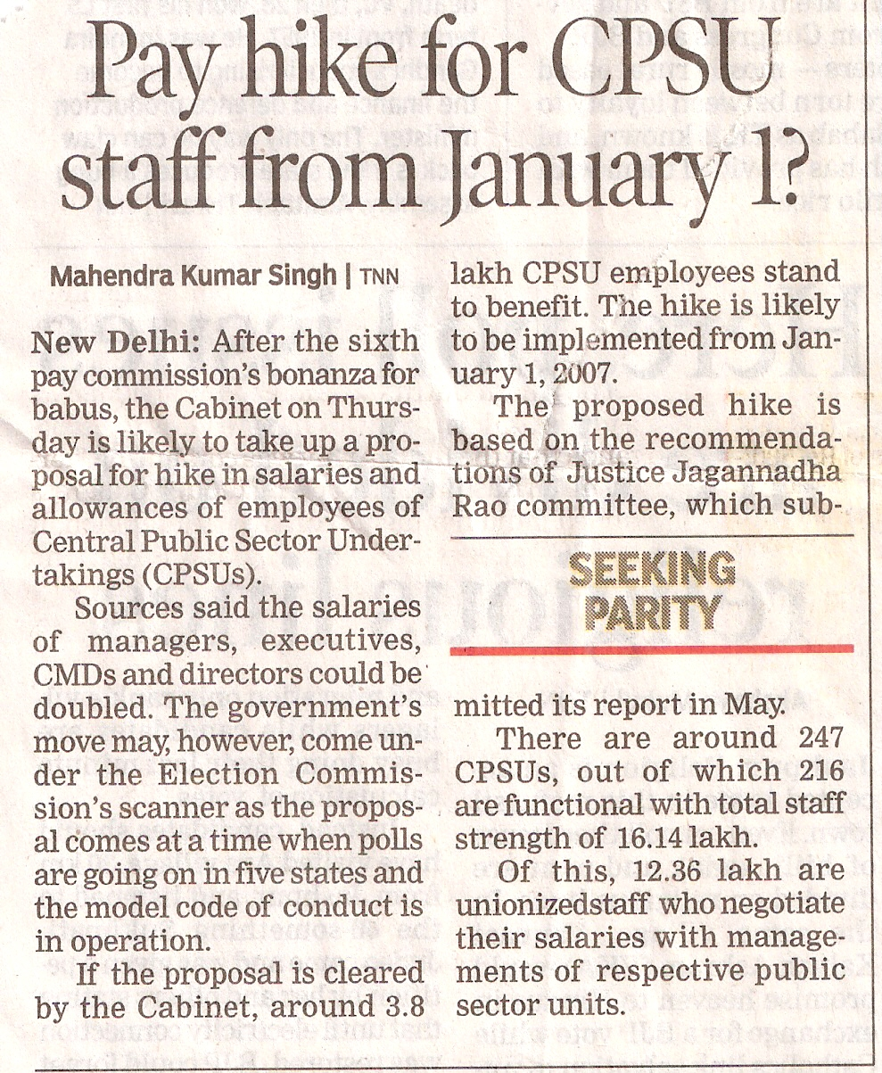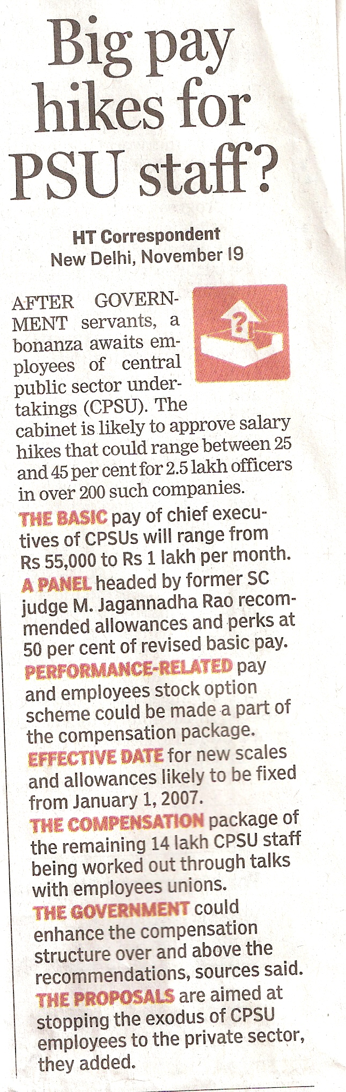
Times of India dated 20/11/2008 Hindustan Times 20/11/2008

