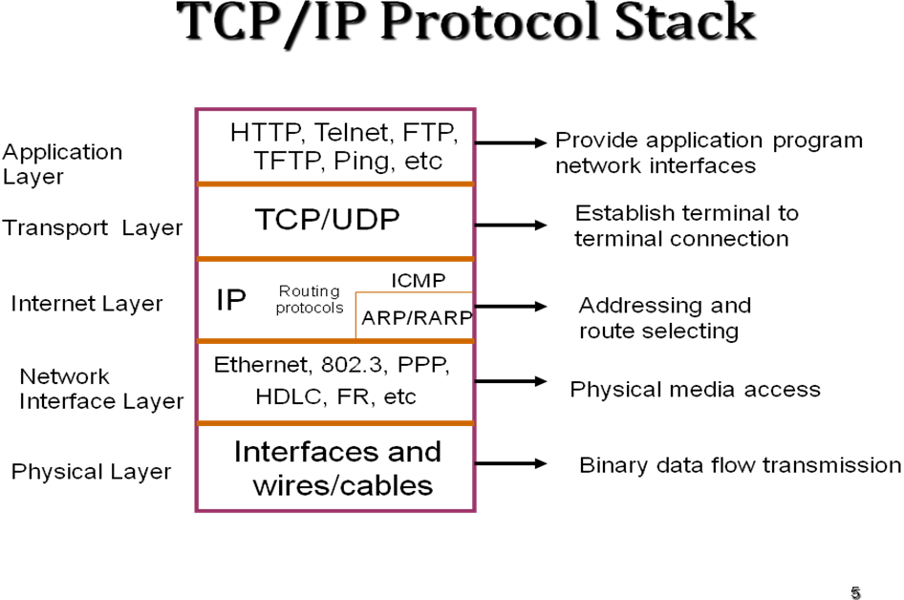
Network COMPONENTS
Repeater, Hub, Bridge, Router, Gateway
REPEATERS
Repeaters are devices that amplify and reshape the signals on one LAN & pass them to another. A repeater forwards all traffic from one LAN to the other. Repeaters are usually used to extend LAN cable distances or connect different media type.
Repeaters connect LANs together at the lowest layer, the Physical layer, of the OSI model. This means that repeaters can only connect identical LANs, such as Ethernet/802.3 to Ethernet/802.3 or Token Ring to Token Ring.
Two physical LANs connected by a repeater become one physical LAN.
HUB
As its name implies, a hub is a center of activity. In more specific network terms, a hub, or concentrator, is a common wiring point for networks that are based around a star topology. Hubs basically act as a signal splitter. They take all of the signals they receive in through one port and redistribute it out through all ports.

Bridges
Bridges connect LANs together at the Data Link layer of the OSI model. Specifically bridges connect at the Media Access Control (MAC) sub-layer of the Data Link layer, and are often referred to as MAC-layer bridges.
Bridges are transparent to the network-layer protocols (such as IPX and IP) being used on the network. Two networks connected via a bridge are physically separate network, but logically a single network. This means that a network’s cabling rules apply to each individual network, not both collectively, but Network-layer protocols will address the bridged network as if they were one.
Bridges segment traffic by only forwarding traffic that is addressed to stations on the opposite side of the bridge. This means that bridges do not forward local traffic. This can considerably reduce overall traffic in a multi-LAN inter-network.
ROUTERS
Routers connect LANs at the Network layer of the OSI model Routers connect LANs that use the same Network-layer protocol, such as IPX-to-IPX and IP-to-IP. Because routers operate at the Network layer, they can be used to link dissimilar LANs, such as ARCNET, Ethernet, and Token Ring.
Two networks connected via a router are physically and logically separate networks. Network-layer protocols have their own addressing scheme separate from the addressing scheme of MAC-layer protocols. This addressing scheme may or may not include the MAC-layer addresses of the network cards. Each network attached to a router must be assigned a logical identifier, or network address, to designate it as unique from other physical networks.
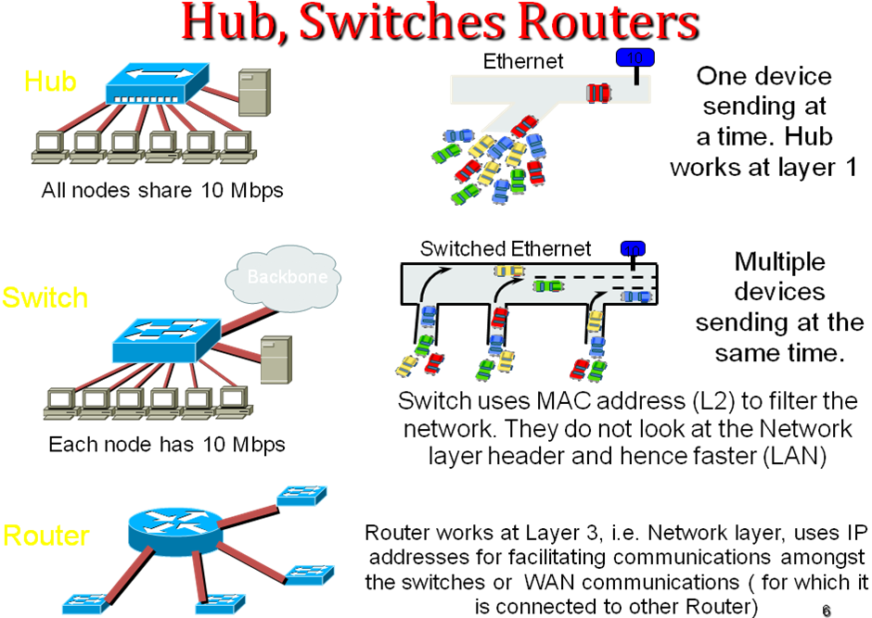

GATEWAYS
A gateway is a fundamentally different type of device than a repeater, bridge, router, or switch and can be used in conjunction with them. A gateway makes it possible for an application program, running on a system, confirming to network architecture, to communicate with an application program running on a system confirming to some other network architecture.
A gateway performs its function in the Application layer of the OSI model. The function of a gateway is to convert one set of communication protocols to some other set of communication protocols.

PHYSICAL LAYER STANDARDS
DTE: Data Terminal Equipment (PC, Terminal, Printer)
DCE: Data Communications Equipment (Modem, Mux, Host/Mainframe)
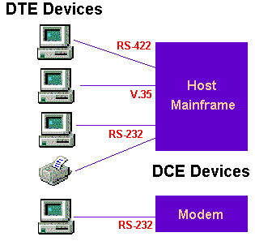

RS-232 (V.24)== RS-232 is a very popular interface for low speed data signals. It is an unbalanced interface capable of operation from 0 to 20 KBPS at 50 feet. RS-232 is a voltage sensing interface, with the Mark (1) voltage being from -3 to -25 VDC and the Space (0) voltage being from +3 to +25 VDC.
V.35 ============= V.35 (.35 is an interface (ITU - formerly CCITT standard) is a high-speed serial interface designed to support both higher data rates and connectivity between DTEs (data-terminal equipment) or DCEs (data-communication equipment) over digital lines. Although V.35 is commonly used to support speeds ranging anywhere from 48 to 64 Kbps, much higher rates are possible [ ISDN (64 or 128Kbps), Factional T1@ 128 Kbps to 1.544Mbps T1, ATM and Frame Relay]. Max speed is 2 Mbit/s.
G703 ========== G.703 is an ITU-T standard for transmitting voice or data over digital carriers such as T1 and E1. G.703 provides specifications for pulse code modulation (PCM). G.703 also specifies E0 (64kbit/s). G.703 is either transported over 75 ohm co-axial cable terminated in BNC or Type 43 connectors or 120 ohm twisted pair cables terminated inRJ48C jacks.
HSSI============= The High- Speed Serial Interface (HSSI) is differential ECL serial interface standard developed by Cisco Systems and T3 plus Networking primarily for use in WAN router connections. It is capable of speeds up to 52 Mbit/s with cables up to 50 feet in length.While HSSI uses 50-pin connector physically similar to that used by SCSI-2, it requires a cable with an impedance of 110Ω (as opposed to the 75Ω of a SCSI-2 cable).
collision domain is a network segment that allows normal network traffic to flow back and forth. In the old days of hubs, this meant you had a lot of collisions, and the old CSMA/CD would be working overtime to try to get those packets re-sent every time there was a collision on the wire (since ethernet allows only one host to be transmitting at once without there being a traffic jam). With switches, you break up collision domains by switching packets bound for other collision domains. These days, since we mostly use switches to connect computers to the network, you generally have one collision domain to a PC.
Broadcast domains are exactly what they imply: they are network segments that allow broadcasts to be sent across them. Since switches and bridges allow for broadcast traffic to go unswitched, broadcasts can traverse collision domains freely. Routers, however, don't allow broadcasts through by default, so when a broadcast hits a router (or the perimeter of a VLAN), it doesn't get forwarded. The simple way to look at it is this way: switches break up collision domains, while routers (and VLANs) break up collision domains and broadcast domains. Also, a broadcast domain can contain multiple collision domains, but a collision domain can never have more than one broadcast domain associated with it.

Comparison of circuit and packet switches
Circuit Switch | Packet switch
Since this switch follows connection oriented routing (dedicated path), without no loss of intelligence. | Since this switch uses connection loss routing, loss of packets may be possible
Latency can be kept within the limit | Latency cannot be maintained
Class of services can be defined | Class of services cannot be defined.
Type of users can be defined | Type of users could not be defined.
Security is high during the transaction, since the switched path could not be intruded. | Security is meager. Intrusion is possible during transaction. Eg. Receiving many advertisements during downloads.
Part of the address of the destination (Rout code, Exchange code, etc.) is analyzed. | Entire address (IP address) is analyzed for selecting best match.
Dedicated path means requirement of more paths. | Same channel can take traffic of lot many conversations ( optimum utilization of valuable trunk network)

Hence, the limitations of the packet network are summarized as follows:
- Creation and processing of routing table is tedious.
- Class of services (Priorities) as in circuit switch is not implemented presently.
- Type of services (category) as in manual board is not available in the present IP network.
- Loss of packet, because of the random routing of packets.
- Delayed processing at receiving end, since packets are not reaching the destination sequentially.
- Security problem.

Label Switching
Above limitations can be overcome by using following techniques in the present IP network.
- Connectionless IP routing is converted into connection oriented routing by overlaying Network Layer function with Data link layer Function.
- IP address is converted as Labels (Route codes in circuit switch), according to the class and type of services like categories and Priorities in circuit switches.
- Intermediate Routers uses the Labels only (Rout Codes in Circuit Switch) for further routing of destined IP packet with appropriate Label.
- The above techniques are used in Multi Protocol Label switching. Hence, MPLs is the implementation of circuit switch model in the Packet switch area. MPLS frame uses the various Data Link frames like ATM, Frame Relay PPP/Ethernet etc (Support multiple Layer-3 protocols, such as IP, IPv6, IPX, SNA, OSPF , BGP, static , RIP etc. ). Since MPLS uses label switching and supports the multiple protocols, it is called Multi Protocol Label Switching.

MPLS

- It aim is to avoid some drawbacks of both circuit switching and packet switching and to increase the utilization of bandwidth. It combines the benefits of both Circuit switching and packet switching .
- MPLS is basically deployed to manage the traffic within the ISP .It uses Circuit switching within ISP. and IP based packet switching within ISPs.
- The general idea behind MPLS is to attach a discrete set of labels to IP packets to perform a specific function, without forcing routers and switches to dive into IP addresses or other information in each packet to obtain instructions relating to that particular function.
- MPLS provides all the required convergence of all type of networks be it IP-network, Next Generation network or our traditional legacy (TDM) network.
- It is a Layer 2+ switching, versatile solution to address the problems faced by present day Network requirements - Speed, Scalability, Quality of Services(QoS) & Traffic engineering.
MPLS Elements & terminologies
- LER - Label Edge Router ( PE- Provider Edge)
- LSR - Label Switch Router (P- Provider or Core Router)
- FEC - Forward Equivalence Class
- Label - Associates a packet to a FEC
- Label Stack - Multiple labels containing information on how a packet is forwarded.
- Shim - Header containing a Label Stack
- Label Switch Path - path that a packet follows for a specific FEC
- LDP - Label Distribution Protocol, used to distribute Label information between MPLS-aware network devices
- Label Swapping - manipulation of labels to forward packets towards the destination.
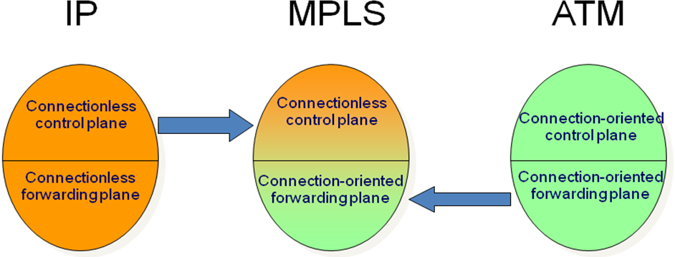
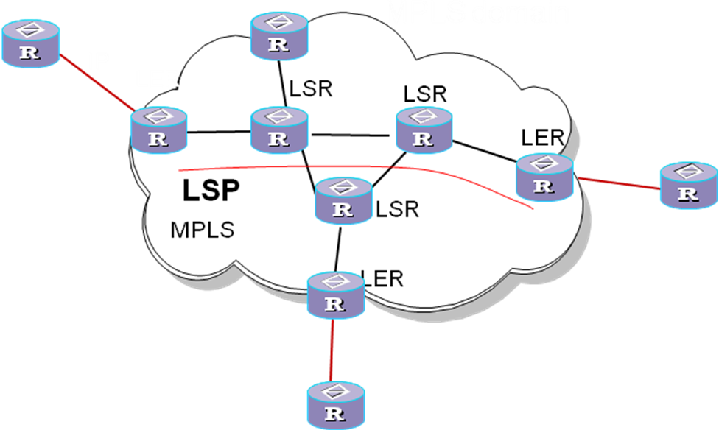
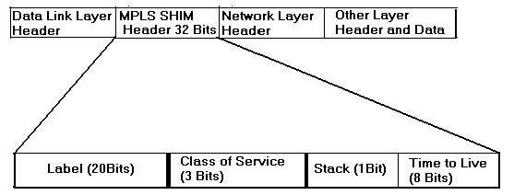
LDP
maps unicast IP destinations into labels. It provides hop-by-hop or dynamic label distribution, using IGP (OSF). The resulting labeled paths, called label switch paths or LSPs, forward label traffic across an MPLS backbone to particular destinations. It uses the request based label distribution also. LDP uses the following events, for distributing labels—
- Discovery messages – announce and maintain the presence of new router in the network.
- Session messages – establish maintain and terminate sessions between LDP peers to exchange messages.
- Advertisement messages-- eate or change or delete mapping for FECs.
- Notification messages – provides signaling error information.

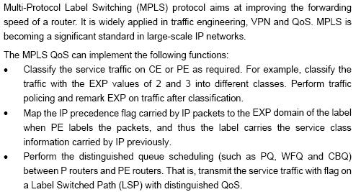
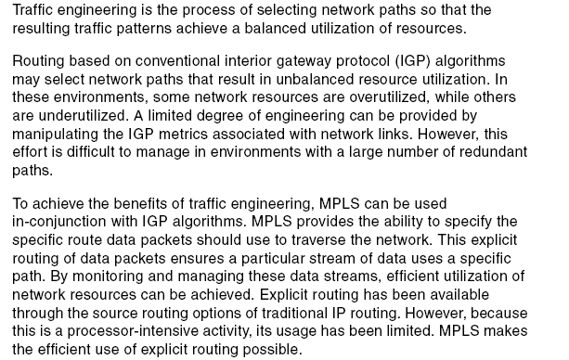
VPN
Branches of Corporate giants are normally distributed geographically over the entire nation at least. Since it is the competitive world, they may require their own private, secured, faster and economical data network between Corporate Office and all branch offices. Construction of their data network is not economical and unwise, because it involves provision of individual paths in between their offices to ensure the safety and authentication. Virtual Private Network comes as the solution of the above problem. Virtual Private Network is Private Data Network, carved out from the Public Data Network. In this concept only switched paths(virtual paths) are assigned between the hosts. VPN can be constructed by using conventional IP network. But the users have to encounter with the defects in present IP backbone as discussed earlier. Since MPLS adopts the connection oriented routing, VPN can be overlaid on MPLS architecture, by constructing Tunnels. Other users according to their FECs can share tunnels.
MPLS VPN is a family of methods for harnessing the power of Multiprotocol Label Switching (MPLS) to create virtual private networks(VPNs). MPLS is well suited to the task as it provides traffic isolation and differentiation without substantial overhead

Layer 3 MPLS VPN
A layer 3 MPLS VPN, also known as L3VPN, combines enhanced BGP signaling, MPLS traffic isolation and router support for VRFs (Virtual Routing/Forwarding) to create an IP based VPN. Compared to other types of VPN such as IPSec VPN or ATM, MPLS L3VPN is more cost efficient and can provide more services to customers.
However, there is no implementation of privacy of the traffic sent over the MPLS, except to the degree that you trust the operator of the MPLS equipment along the way. If privacy is a concern, other encryption method such as end-to-end IPSec tunnels should be considered before injecting the traffic to MPLS backbones.
